# Create maven settings.xml with credentials for developer workstation

* CLI to generate the file (Recommended)
* Manual Steps Getting auth credentials for your account
* Download, update and copy settings.xml on developer workstation
  + References:

## CLI to generate the file (Recommended)

* Go to <http://go/settings-gen>
* Download the cli based on your operating system
* Follow the instructions in the download page.

## Manual Steps Getting auth credentials for your account

**[ Using UI to get API key] - Refer** [**How to get Artifactory API key**](https://wiki.corp.ebay.com/display/scmteam/FAQ+%7C+How+to+Get+API+Key) **to generate the API key once the UI option is removed**

* Navigate to <https://ebaycentral.qa.ebay.com/ui/login/> and login with your LDAP credentials

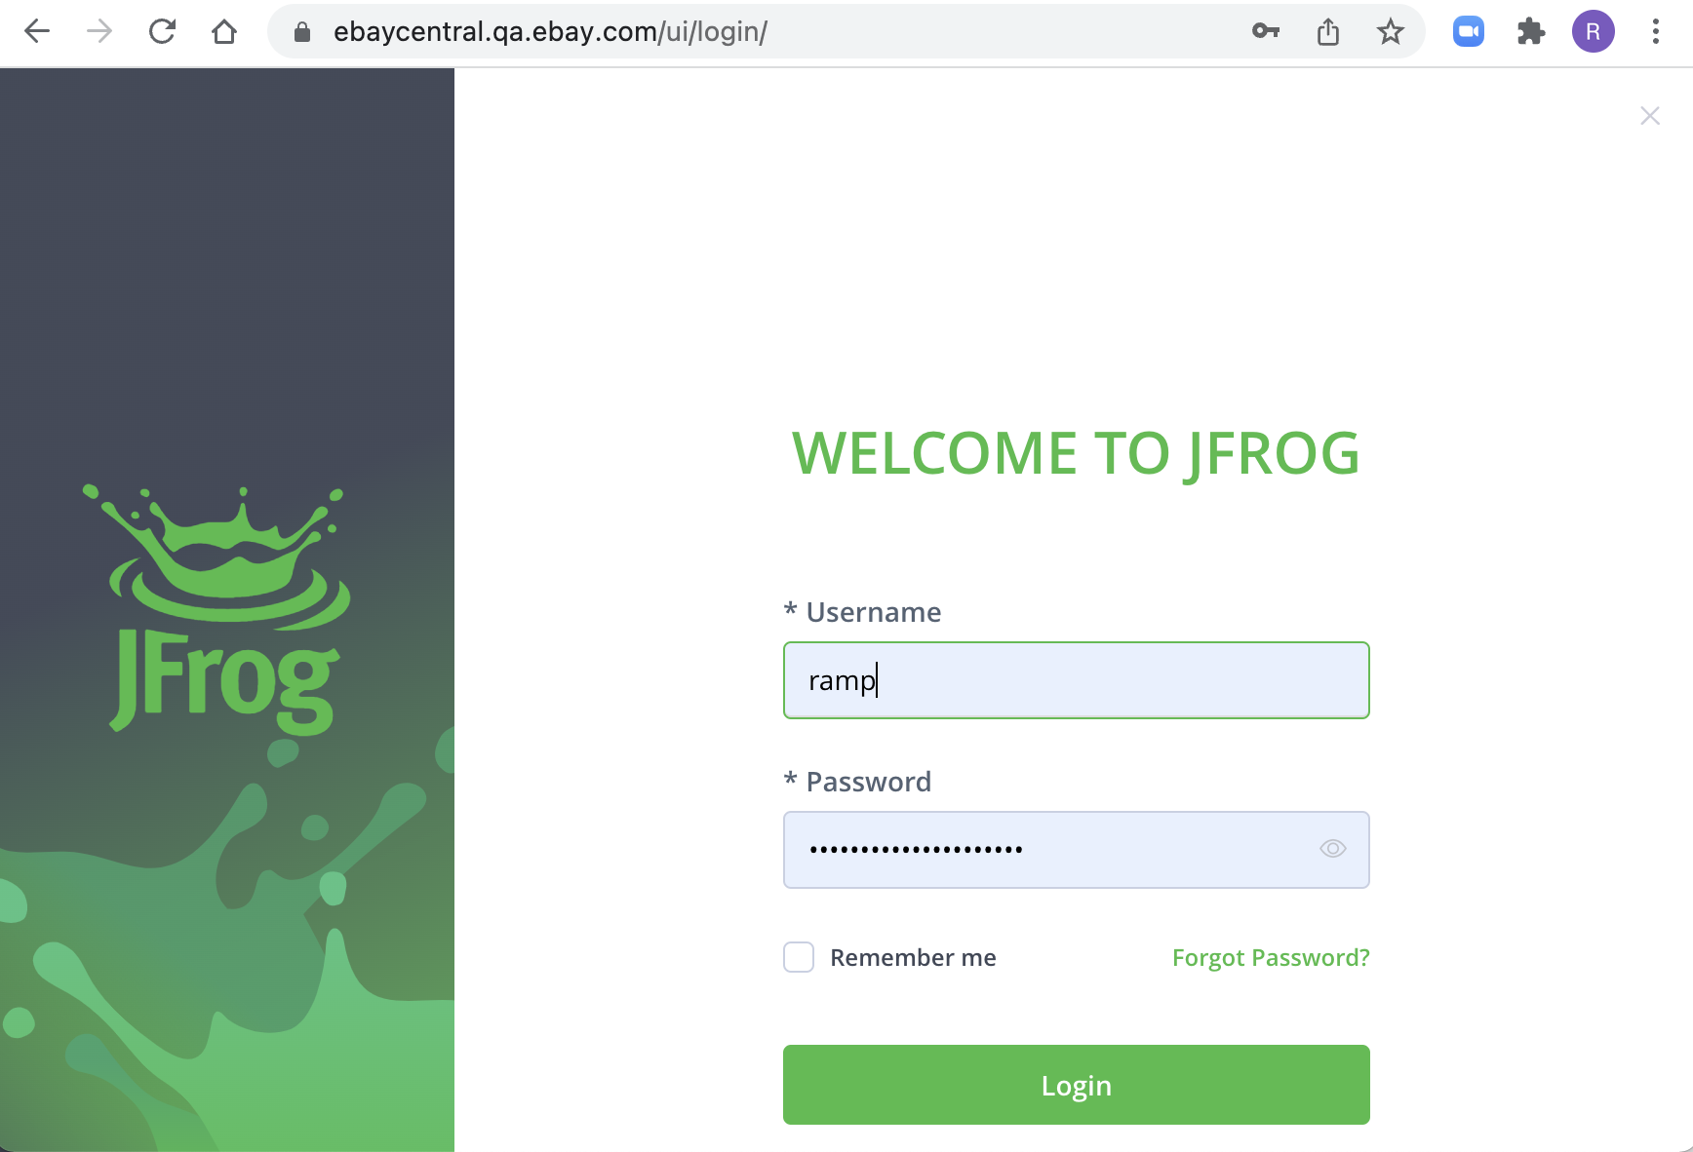

* Navigate to <https://ebaycentral.qa.ebay.com/ui/admin/artifactory/user_profile>  
  You can navigate to the URL By clicking top right Corner of the page and Choose edit profile after logging in

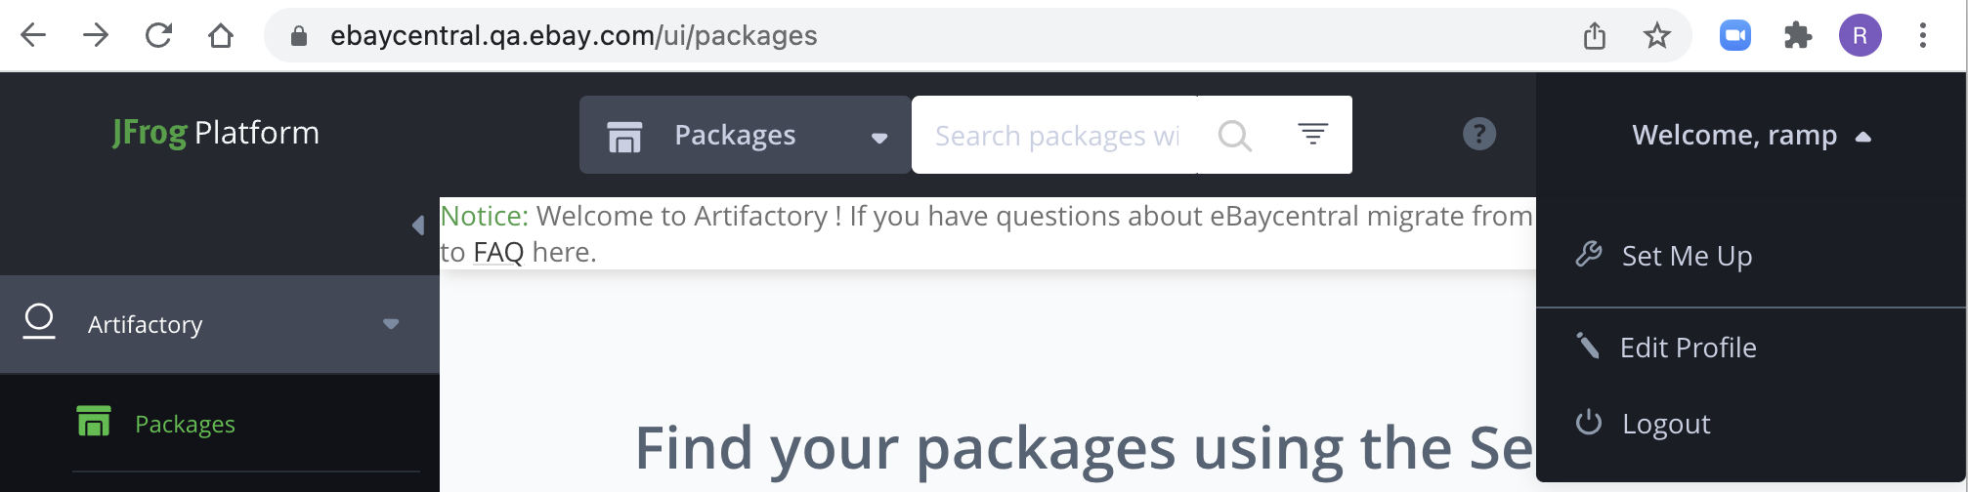

* Enter your LDAP password and click on Unlock

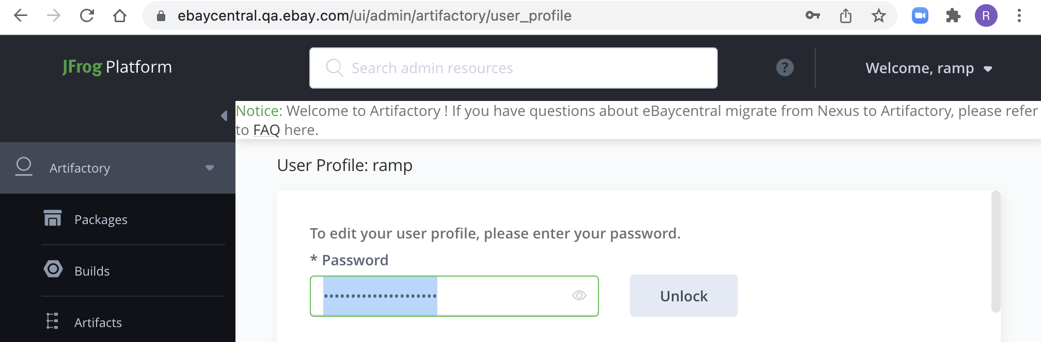

* Once Unlocked, scroll down to section API Key and click on button **Generate API Key**and click on the copy button next to the text field  
  **Then click on Save button and keep the copied API key in TextEditor/Notepad**
* Please note that you **can also revoke your API key** if you find it is not available anymore.

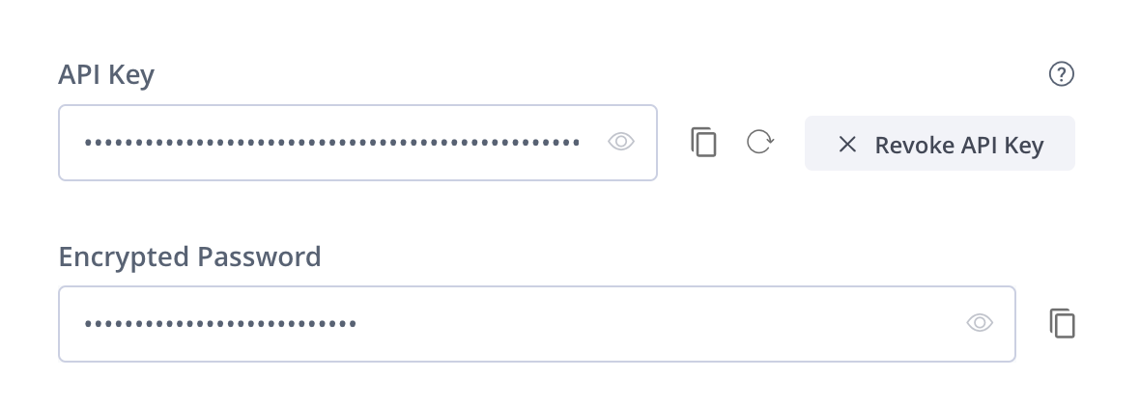

**[ Using REST API to get API key]**

1.If you've already generate your api key, and just want to retrieve it.

|  |
| --- |
| curl -u '<nt account>:<ldap password>' https://[artifactory.qa.ebay.com/artifactory/api/security/apiKey](http://artifactory.qa.ebay.com/artifactory/api/security/apiKey) |

**Note**: if you met 401 Error with above command, check if your password is correct.

2.If above shows empty result or you have not generated your api key. Use below cli to generate a new one.

|  |
| --- |
| curl -X POST -u '<nt account>:<ldap password>' https://[artifactory.qa.ebay.com/artifactory/api/security/apiKey](http://artifactory.qa.ebay.com/artifactory/api/security/apiKey) |

3.If you want to re-create a new api key.

|  |
| --- |
| curl -X PUT -u '<nt account>:<ldap password>' https://[artifactory.qa.ebay.com/artifactory/api/security/apiKey](http://artifactory.qa.ebay.com/artifactory/api/security/apiKey) |

4. If you have problems in retrieving API keys created/existed, please contact Artifactory admin to revoke the key for you. (This requires an admin account to run the command.)

|  |
| --- |
| curl -X DELETE -u '<admin ldap account>:<admin ldap password>' https://[artifactory.qa.ebay.com/artifactory/api/security/apiKey/{username](http://artifactory.qa.ebay.com/artifactory/api/security/apiKey/%7busername)} |

## Download, update and copy settings.xml on developer workstation

* Go to <https://artifactory.qa.ebay.com/ui/native/releases/com/ebay/settings/authenticated> and click on settings.xml  (Download directory Ex: {User_Home}/Downloads )
* Open the settings.xml and do the following
  + Replace all ${mvnrepo.username} with your LDAP username
  + Replace all ${mvnrepo.password} with the API key copied from the previous section
  + Save the file with changes.

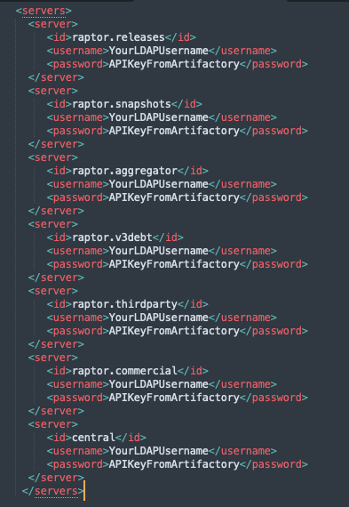

* Once this change is done, copy updated settings.xml file to $USERHOME/.m2 folder
  + On windows C:\Users\<Your LDAP Username>\.m2
  + On Mac just copy the file to ~/.m2 folder or copy to /Users/<Your LDAP Username>/.m2

After this change, maven uses credentials to download artifacts from ebaycentral.qa.ebay.com. You can confirm this by running mvn clean install -X -DskipTests and you will see the debug log as follows

[DEBUG] Using connector BasicRepositoryConnector with priority 0.0 for https://ebaycentral.qa.ebay.com/content/groups/aggregator/ with username=ramp, password=***

### References:

<https://www.jfrog.com/confluence/display/JFROG/User+Profile>

Artifactory Authentication

<https://stackoverflow.com/c/ebay/articles/6234>